Y12 Developing Competency in D&T
- Taps and Dies

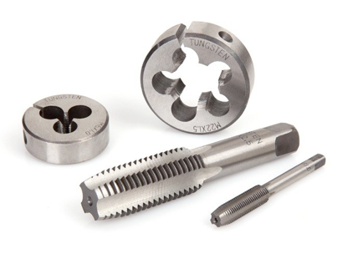

A basic engineering exercise: make internal and external threads using appropriate techniques.

Machine / Tools used:
- Taps & Dies
- Threading Compound

Materials used:
- 30mm Aluminium Hex Bar

Processes:
- Taping an External Thread
- Taping an Internal Thread

COSHH: Metalwork Fluids and Threading Compound

BS4163:2007:

CLEAPSS:

Notes:

