Y12 Developing Competency in D&T
- Centre Lathe

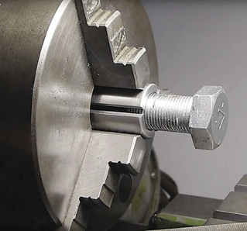

A basic engineering exercise: interpret and accurately transfer an engineering drawing to a piece of Aluminium hex bar and then fashion a nut and bolt using appropriate techniques.

Machine / Tools used:
- XL-1220 Centre Lathe
- Taps & Dies

Materials used:
- 30mm Aluminium Hex Bar

Processes:
- Facing Off
- Parallel Turning
- Parting Off
- Centre Drilling
- Taping a Thread

COSHH: Metalwork Fluids and Threading Compound

BS4163:2007: Section 11.2 Centre Lathes

CLEAPSS: Section 1.037 Metal Working Lathes – Metal Turning

HEALTH & SAFETY notes for the removal of SWARF:
- Never allow swarf to accumulate around the chuck
- Never by hand – swarf is extremely sharp and can be hot
- Never whilst the machine is in operation

HEALTH & SAFETY: Never use a centre lathe without permission or unaccompanied.

