Y12 Developing Competency in D&T
- Cutting & finishing sheet metal

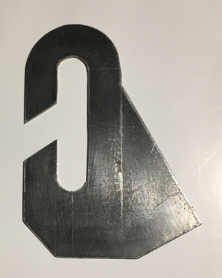

A basic engineering exercise: interpret and accurately transfer an engineering drawing to a piece of mild steel and then cut it out using appropriate wasting techniques.

Drawing Tools used:
- Steel ruler
- Scribe
- Calipers
- Odd Leg Calipers
- Compass
- Engineers’ Blue
- Engineers’ Square

Materials used:
- 2mm Sheet Mild Steel

Wasting Tools:
- Centre Punch
- Pillar Drill & HSS Drill Bits
- Hacksaw
- Flat and Round Files
- Emery Paper
- Wet & Dry Paper

Processes:
- Drilling
- Cross Filing
- Draw Filing
- Polishing

COSHH: COSHH is the law that requires employers to control substances that are hazardous to health.

BS4163:2007: Health and safety for design and technology in schools and similar establishments.

CLEAPSS: CLEAPSS is an advisory service providing support in science and technology.

