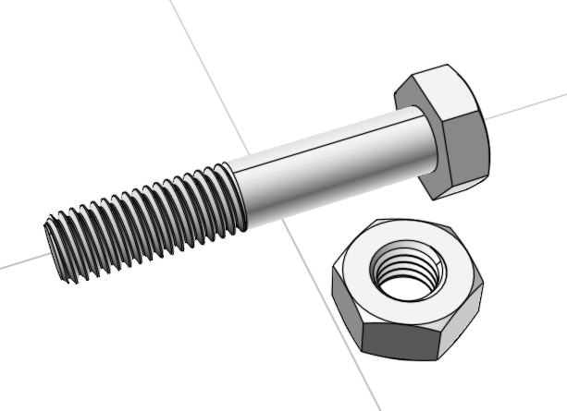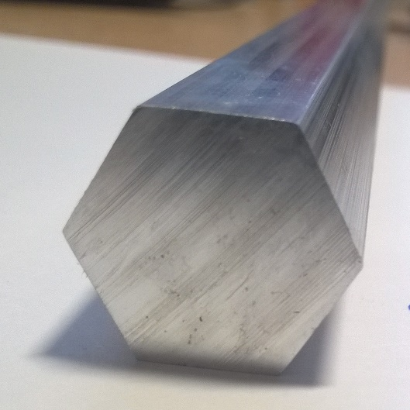
Aluminium Screw and Nut
A beginner’s lathe project
Copyright: Sutton Grammar School 01/11/2017

This project is intended for use by those who have been shown the basics of how a lathe works and have received appropriate Health and Safety training on its use. It is not designed to produce a usable item, more an ornament. The oversize head and nut are to aid production using standard 18mm AF Aluminium hex rod that is available.
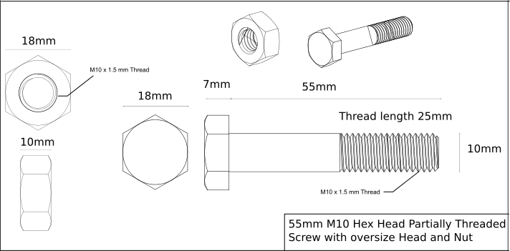
Materials needed:
100mm length of 18mm AF hex rod should be the maximum needed per pupil.

55mm M10 Hex Head Partially Threaded Screw with Oversize Head
Tooling needed:
Right Handed turning tool;
Parting tool;
M10x1.5mm Die and holder;
AnchorLube;
File;
Deburring tool.

Production process:
- Insert 18mmAF Hex Rod into 3-Jaw chuck and secure;
- Using Right Handed Turning Tool, face the end of the Hex Rod (c.535rpm);
- Mark the Hex Rod 55mm from the end;
- Using Right Handed Turning Tool, turn down the first 55mm to a diameter of 10mm (c.1350rpm);
- Using the M10 Die and holder, thread the first 25mm of the screw blank;
- Mark the Head of the Screw on the remaining Hex Rod at a distance of 7mm;
- Using the Parting Tool to the left of the marked line to part off the Screw (use a low speed c. (use a low speed c. 125rpm) and use Anchorlube diluted 3:1 with water;
- With a file, deburr the Head of the Screw.

M10 Nut with Oversize Head
Tooling needed:
Right Handed turning tool;
Parting tool;
Centre Drill and Drill Chuck,
Taper Shank 8.5mm Drill Bit;
M10x1.5mm Tap and holder;
AnchorLube;
File;
Deburring tool;
Countersink.

Production process:
- Insert 18mmAF Hex Rod into 3-Jaw Chuck and secure;
- Using Right Handed Turning Tool, face the end of the rod;
- Adjust the Compound Slide to use the Right Handed Turning Tool to chamfer the end of Hex Rod;
- Reset the Compound Slide to 90º
- Mark the Hex Rod at a distance of 10mm from the end;
- Using the Parting Tool to the left of the marked line to part off the nut blank (use a low speed c. 125rpm and Anchorlube diluted 3:1 with water);
- With a file, deburr the nut blank.
- Insert the nut blank into 3-Jaw Chuck and secure;
- Adjust the Compound slide to use the Right Handed Turning Tool to chamfer the end flat side of the nut blank;
- Using the Centre Drill in the Tailstock mounted Drill Chuck, drill to a depth of 3mm;
- Remove the Drill Chuck from the Tailstock;
- Insert Taper Shank 8.5mm Drill Bit into the Tailstock;
- Using the 8.5mm Drill, drill through the nut blank;
- Remove the nut from the 3 Jaw Chuck;
- Using the countersink on the holes on both sides of the nut;
- Insert the nut blank back into 3-Jaw chuck and secure;
- Apply some neat AnchorLube to the M10 Tap.
- Using the M10 Tap and holder, thread the nut fully;
- Remove completed nut.

